Institute of Engineering & Management


Management House, D-1, Sector-V, Salt Lake

Electronics Complex,

Kolkata – 700 091, West Bengal, India.

PROPOSAL FOR THE FORMATION OF THE

CENTRE OF EXCELLENCE FOR CLOUD COMPUTING & IOT
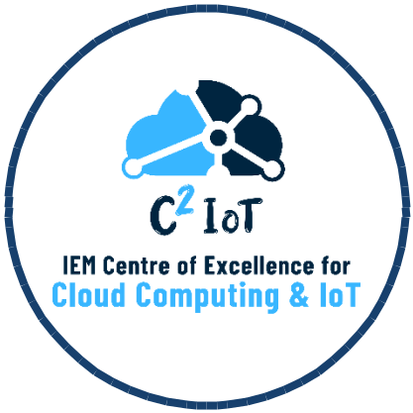

The Centre of Excellence for Cloud Computing and IOT Data Science would be established with the goal of exploring cutting edge technologies such as Cloud Computing, Internet of Things, Edge and Fog Computing, Information Security, Drone Technologies and so on. The centre aims to set-up a state-of-the-art cloud infrastructure to produce top quality publications and patents along with promotion of industry – academia relations and inter-disciplinary collaborations with reputed national and international organizations.

OBJECTIVES

- To groom students for conducting research and development in the field of Cloud Computing & Internet of Things

- To setup and deploy state-of-the-art cloud infrastructure.
- To publish high quality research papers and patents
- To acquire project grants from funding agencies
- To develop IoT based solutions to tackle real-world challenges

SCOPE OF RESEARCH
- IoT Security
- Robotics
- Drone Technology
- Edge Computing

- Autonomous Vehicles
- Fog Computing
- Network Security
- Wireless Sensor Networks
- 5G Networks
- Cloud Computing
- Parallel Processing
- Cloud Infrastructure

- AR/VR/MR
OBLIGATION

- The CoE should ensure that cloud computing & IoT technologies are used ethically and responsibly, with respect for individuals' privacy and other rights.
- CoE should ensure that all data is collected, stored, and processed in accordance with applicable laws and regulations, and that appropriate measures are taken to protect sensitive data.

- CoE will aim in solving national level problems and will work towards country’s benefit.
- The CoE should continuously monitor its activities, technologies and practices to identify and address any ethical issues that may arise, and to ensure that its work remains aligned with the organization's values and ethical principles.
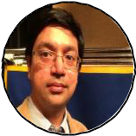
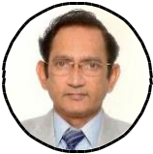

PRESIDENT | CHAIRMAN
Prof. (Dr.) Satyajit | Prof. (Dr.) Satyajit Chakrabarti
Chakrabarti | Director, IEM
President, IEM
CONVENOR | CENTRE IN-CHARGE
Prof. Amartya Mukherjee, | Prof. Ayan Kumar Panja
HoD, CSE(AIML), CSBS | Asst. HoD. CSE(AIML), CSBS
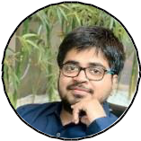


MENTORS



Prof. (Dr.) Deepsubhra Guha Roy | Prof. Pabak Indu
Dept. of CSE(AIML),CSBS | Dept. of CSE(AIML),CSBS
Cloud Computing, IoT, Data | Information Security
Science
Prof. (Dr.) Sumana Sinha | Prof. Tanima Bhowmik
Dept. of CSE(AIML),CSBS | Dept. of CSE(AIML),CSBS
Network Communication | IoT, WSN, VLSI Design, VHDL
Prof. (Dr.) Priti Deb | Prof. (Dr.) Swati Chowdhuri
Dept. of MCA | Dept. of EEE
5G, Mobile Computing, IoT | Wireless Networking



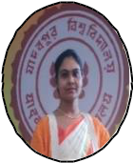

Student Member
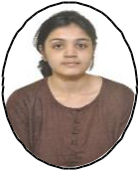

Urbi Basu
Junior Research Fellow,

Under supervision of Prof. Swati

Chowdhuri
EEE Dept

Basic Requirement:

